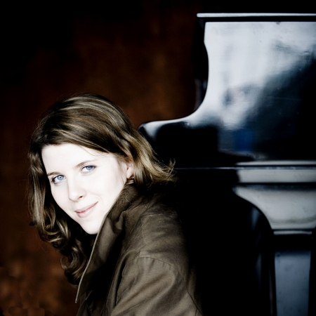
Polina Leschenko The Russian pianist, Polina Leschenko, was born into a family of musicians and began playing the piano under her father’s guidance at the age of 6. She made her solo début at the age of eight with the Leningrad Symphony Orchestra in St Petersburg. She studied with Sergei Leschenko, Vitali Margulis, Pavel Gililov, Alexandre Rabinovitch-Barakovsky and Christopher Elton. At the age of 16 she received her Higher Diploma with the greatest distinction from the Royal Conservatory in Brussels. Polina Leschenko’s recent engagements have included recitals in Berlin, Luxembourg and Milan as well as appearances at the Festivals of Osnabrück and Sintra and at the Festival ‘Progetto Martha Argerich’ in Lugano. She made her débuts last season with the Bournemouth Symphony Orchestra and with the Hallé Orchestra, which was so successful that she was immediately reinvited for several dates this season, with Mark Elder and Cristian Mandeal. In November 2006, Polina Leschenko took part in a major tour with the Australian Chamber Orchestra, playing Felix Mendelssohn’s double concerto with Richard Tognetti. The tour was hugely successful and resulted in an immediate reinvitation. Other engagements with orchestras this season include the Orquesta de Euskadi, the Hallé Orchestra, Russian National, London Mozart Players and Scottish Chamber Orchestra. She will give recitals in Vienna, Minnesota, Atlanta and New York. This season Polina Leschenko is the Palais des Beaux Arts’ candidate for the ECHO Rising Stars series. Together with the cellist Christian Poltéra, she will appear throughout Europe, including Vienna, Salzburg, London, Amsterdam, Paris, Brussels as well as at Carnegie Hall, New York. An accomplished and admired chamber musician, Polina Leschenko will also perform at many festivals this summer, including Risor, West Cork, Moritzburg, and Musiktage Mondsee. She performs regularly with artists including Heinrich Schiff, Ivry Gitlis, Christian Poltera, the Capuçon brothers, Alexander Sitkovetsky, Natalie Clein and Priya Mitchell. Polina Leschenko has recorded a début CD for EMI in the series ‘Martha Argerich presents …’ with works by Franz Liszt, Chopin, Kreisler/Sergei Rachmaninov, Johannes Brahms and Bach-Feinberg. The Gramophone described her as having ‘technical dexterity in abundance, and signs of a major artist in the making’. She has recently recorded a well-received disc of Prokofiev chamber music with Martha Argerich, Christian Poltéra and Roby Lakatos, for PureMusic. And her latest disc - a Liszt recital, including the B minor Sonata - has just been released by PureMusic. Martine Dumont-Mergeay wrote in La Libre Belgique (July 4, 2007): "Polina Leschenko has matured without having lost any of her freedom. Now even more inspired, she turns her wonderful talents to a brilliant, almost improvisatory reading of the Liszt repertoire. Beautifully acknowledging Bach, Busoni and Gounod’s Liszt transcriptions in the first half of the disc, she then offers a unique and personal version of the Sonata: a visionary reading full of lucidity.”

